Photo Essay
Student Name
Institution Affiliation
Course
Date
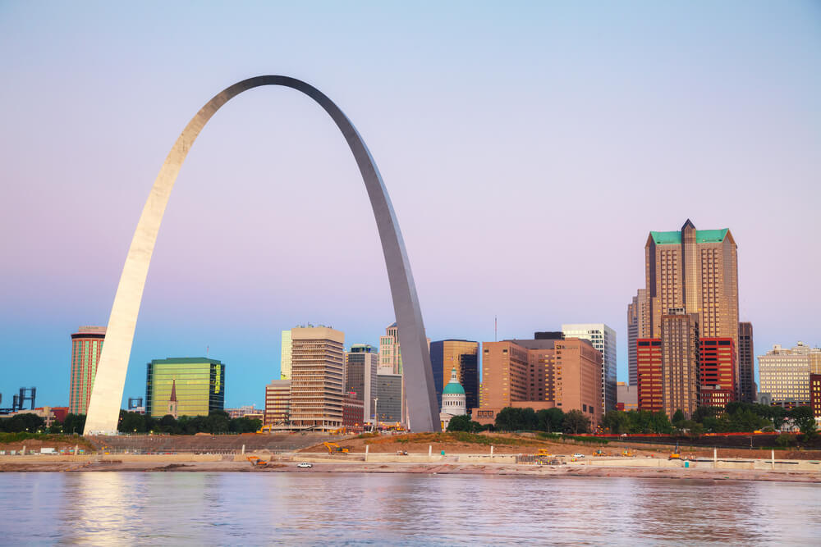
All architectures are engineers and all engineers are not architectures! The above picture is a building found in the United States of America. It is among the best and outstanding buildings I have witnessed so far from the places I have visited in the United States of America. As it is said that good work never goes unrewarded, I acknowledge the design team, civil engineer, mechanical as well as electrical engineers of the building. My warm gratitudes are passed to the architectural team of the building in a special way and the main contractor who had the initiative of constructing the building despite the provision of the plan and quotation of what is needed. To me, the picture means that architectures can do what engineers can do but engineers can not do what architectures can do. The building is known of an event that took place after the completion of it to award the design team of the outstanding building as well as giving an analysis of how the planning of the building took place.
The building being discussed has a lot of positive implications for me as an upcoming engineer. According to me, the picture reveals that we can do well in everything provided we collaborate and show unity. Also, accepting that we can not perfect everything and learning to be emphasizing on quality can result in positive outcomes. In relation to our picture, it is a clear indication that the building needed collaboration as well as unity for it to appear the way it is. In many situations, people who are engaged in one project but to be having different departments tend to behave in a bad way. For instance, they show division because every party is acting independently even though they are all in the same project. Moreover, it is possible and always a common thing to find out one party to do something with the aim of getting the final pride. Surprisingly, this is not the way things were done in the construction of the building in the picture. For it to be achieved to have a unique and long-lasting building, the architectural team seems to have collaborated and showed unity with all other members of the parties involved in the construction of the project, factors which are the key factors in every project we engage ourselves in.
I have emotions such as contentment, gratification, joy, satisfaction, and pride emotions towards the building in the picture. As an upcoming, determined, creative, and upcoming engineer, I poses a feeling that the picture implies that there are great innovations and creativity that are taking place in the world. Nevertheless, my emotions make me be proud of being associated with good and unique things. It is true that there are thousands of good buildings in the United States of America but there is none that has gotten my attention like the building in the picture at the top of the paper. Also, I satisfaction feeling because since childhood has been seeking how I can associate myself with people who are unique and creative. To elaborate on this, uniqueness is applied in the building because it is the only tall-curved building in the United States of America. Other than the shape, the building is built at the shores of a water body, a place where is considered to have a low bearing capacity. Interestingly, the design team and the builders have managed to build a strong and stable building at a such place that has low bearing capacity.
The moment I hear analysis and illustration of how the building was built, I always feel motivated and encouraged. Additionally, I always challenge myself by saying that if people have constructed such outstanding buildings I will also specialize in the field. Unfortunately, I also feel challenged. We know that for something to do well we should show unity and collaboration. As a result of my determination and focus on always doing an extra of what has been done by the others, I am challenged to see that there is no one who has designed the house, worked as a civil engineer and a contractor at the same time. They all have to divide the work into different parties something aiming at specialization. This pushes me to work hard to emerge as the first person who can do all those things in one.
Also, whenever I hear illustration of how the building was managed for it to be stable with that shape I feel so appreciated even if am not among the members who did the work. It's not a normal thing to have a curved building that is not supported in the middle yet it is high and built at an area of low bearing capacity. Such an event on television makes me see the power of structural work because it's the only way we can manage to get such a building that has a huge load on being supported at the two ends. Furthermore, there is an event on the presentation of advanced, prioritized, and qualified architectures, engineers, contractors, and building materials that took place in the building. Once I hear that event on the television, I always feel in the right line. I get a serenity because people who engage themselves in my dream career have done good and recommendable work which has aided in the marketing of our career hence giving a lot of considerations and being appreciated by everyone in what we do.

